FLOWCHARTS

Flowcharts are the best way to represent the algorithm by graphical designs.
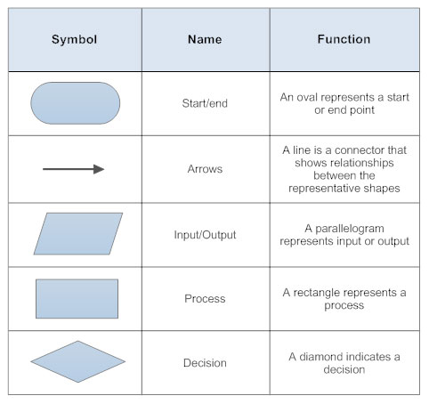
There are some basic components for the flow chart such as

A flowchart contains some components
- Sequence flow
- Selection
- Repetition
- Loop

